- DFS and BFS
from collections import deque
g = {1:[2,3], 2:[4], 3:[4], 4:[5]}
def dfs(u, goal, v=[], p=[]):
v.append(u); p.append(u)
if u==goal: return p
for x in g.get(u,[]):
if x not in v:
r=dfs(x,goal,v,p)
if r: return r
p.pop(); return None
def bfs(s, goal):
q=deque([(s,[s])]); v={s}
while q:
n,p=q.popleft()
if n==goal: return p
for x in g.get(n,[]):
if x not in v: v.add(x); q.append((x,p+[x]))

print("DFS:", dfs(1,5))
print("BFS:", bfs(1,5))

OUTPUT:
DFS: [1, 2, 4, 5]
BFS: [1, 2, 4, 5]

- Hill Climbing:
import numpy as np
def f(x): return -x**2 + 5
def neigh(x, s=0.1): return [x+s, x-s]
x = 2.0
for i in range(100):
n = neigh(x)
best = max(n, key=f)
if f(best) > f(x):
x = best
print(f"Step {i+1}: x={x:.4f}, f(x)={f(x):.4f}")
else:
print("Converged"); break
print(f"\nBest x={x:.4f}, f(x)={f(x):.4f}")
OUTPUT:
Step 1: x=1.9000, f(x)=1.3900
Step 2: x=1.8000, f(x)=1.7600
Step 3: x=1.7000, f(x)=2.1100
Step 4: x=1.6000, f(x)=2.4400
Step 5: x=1.5000, f(x)=2.7500
Step 6: x=1.4000, f(x)=3.0400
Step 7: x=1.3000, f(x)=3.3100
Step 8: x=1.2000, f(x)=3.5600
Step 9: x=1.1000, f(x)=3.7900
Step 10: x=1.0000, f(x)=4.0000
Step 11: x=0.9000, f(x)=4.1900
Step 12: x=0.8000, f(x)=4.3600
Step 13: x=0.7000, f(x)=4.5100
Step 14: x=0.6000, f(x)=4.6400
Step 15: x=0.5000, f(x)=4.7500
Step 16: x=0.4000, f(x)=4.8400
Step 17: x=0.3000, f(x)=4.9100
Step 18: x=0.2000, f(x)=4.9600
Step 19: x=0.1000, f(x)=4.9900
Step 20: x=-0.0000, f(x)=5.0000
Converged
Best x=-0.0000, f(x)=5.0000

- Knowledge Based Agent for Wumpus world
class KB:
def __init__(s): s.f=set()
def tell(s,f): s.f.add(f)

class WumpusAgent:
def __init__(s):
s.kb=KB(); s.gold=False
def run(s):
world={(0,0):["Breeze"],(0,1):["Stench"],(1,0):[],(1,1):["Breeze"]}
for loc, percepts in world.items():
for p in percepts: s.kb.tell((p,loc))
if "Glitter" in percepts: s.gold=True
print("Gold found" if s.gold else "Gold not found")
WumpusAgent().run()
OUTPUT:
Gold not found

- Knowledge Representation schemes
facts = {"raining","cloudy"}
rules = [ (["raining"],"wet_ground"), (["cloudy"],"maybe_rain"), (["raining","cloudy"],"umbrella_needed") ]
changed = True
while changed:
changed = False
for pre, con in rules:
if con not in facts and all(p in facts for p in pre):
facts.add(con)
changed = True

print("All facts:", facts)

OUTPUT:
All facts: {'cloudy', 'wet_ground', 'raining', 'umbrella_needed', 'maybe_rain'}

- Forward state space planning alg
from collections import deque

class A:
def __init__(s,n,p,a,d=[]): s.n,p,s.a,s.d=n,set(p),set(a),set(d)
def apply(s,state): return (state - s.d) | s.a

def plan(init,acts,goal):
q,vis=deque([(init,[])]),{frozenset(init)}
while q:
s,p=q.popleft()
if goal<=s: return p
for a in acts:
if a.n<=s:
ns=frozenset(a.apply(s))
if ns not in vis: vis.add(ns); q.append((ns,p+[list(a.a)]))
return None

init=frozenset({"onA_table","clearA","onB_table","clearB"})
acts=[A(frozenset(["onA_table","clearA"]),["holdingA"],["onA_table","clearA"]),
A(frozenset(["holdingA","clearB"]),["onA_B"],["holdingA","clearB"])]
goal=frozenset(["onA_B"])
print("Plan:", plan(init,acts,goal))

OUTPUT:
Plan: None

- Simple and polynomial Regression
import numpy as np, matplotlib.pyplot as plt
from sklearn.linear_model import LinearRegression
from sklearn.preprocessing import PolynomialFeatures
from sklearn.model_selection import train_test_split
from sklearn.metrics import r2_score

X,y=np.arange(1,11).reshape(-1,1),np.array([35000,38000,42000,46000,50000,55000,60000,65000,70000,75000])
Xtr,Xte,ytr,yte=train_test_split(X,y,test_size=0.2,random_state=42)

lr=LinearRegression().fit(Xtr,ytr)
poly=PolynomialFeatures(2); pr=LinearRegression().fit(poly.fit_transform(Xtr),ytr)

print("R² Linear:", r2_score(yte,lr.predict(Xte)))
print("R² Poly:", r2_score(yte,pr.predict(poly.transform(Xte))))

plt.scatter(X,y)
plt.plot(X,lr.predict(X),'r',X,pr.predict(poly.transform(X)),'g');
plt.show()

OUTPUT:
R² Linear: 0.998779296875
R² Poly: 0.9997211508583043
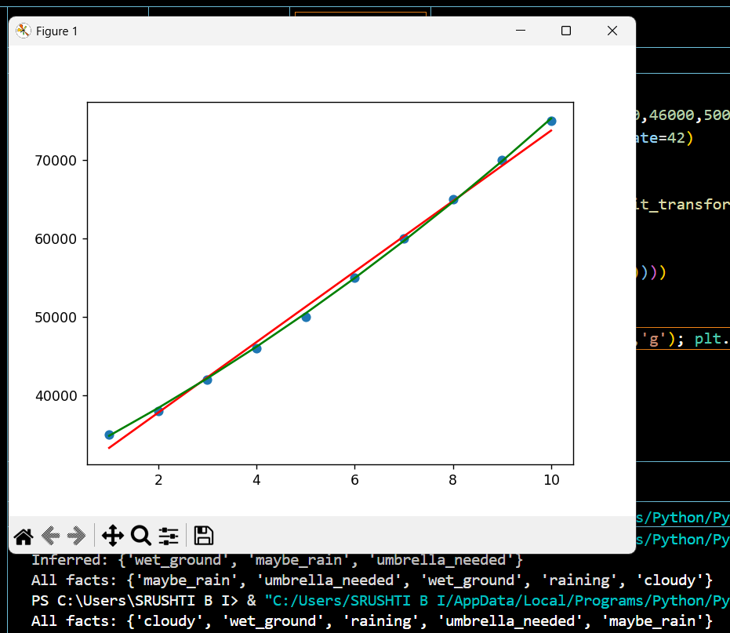

- KNN On Indian diabetes patient
import numpy as np,
matplotlib.pyplot as plt

X=np.array([[2,120,70,20,80,25,0.5,30],[4,150,80,25,90,30,0.7,45],
[1,85,60,18,60,22,0.3,25],[6,180,90,30,120,35,0.9,50],
[3,95,65,20,70,23,0.4,28],[5,160,85,28,100,33,0.8,48]])
y=np.array([0,1,0,1,0,1])

X=(X-X.mean(0))/X.std(0)
def knn(X,y,q,k=3):
d=np.sqrt(((X-q)**2).sum(1)); r
eturn int(round(y[np.argsort(d)[:k]].mean()))

q=np.array([2,130,72,22,85,26,0.6,32]); q=(q-X.mean(0))/X.std(0)
print("Prediction (1=Diabetic,0=Not):", knn(X,y,q))

plt.scatter(X[:,1],X[:,7],c=y,cmap="coolwarm",s=100)
plt.xlabel("Glucose"); plt.ylabel("Age");
plt.title("Diabetes Prediction using KNN");
plt.show()
OUTPUT:
Prediction (1=Diabetic,0=Not): 1
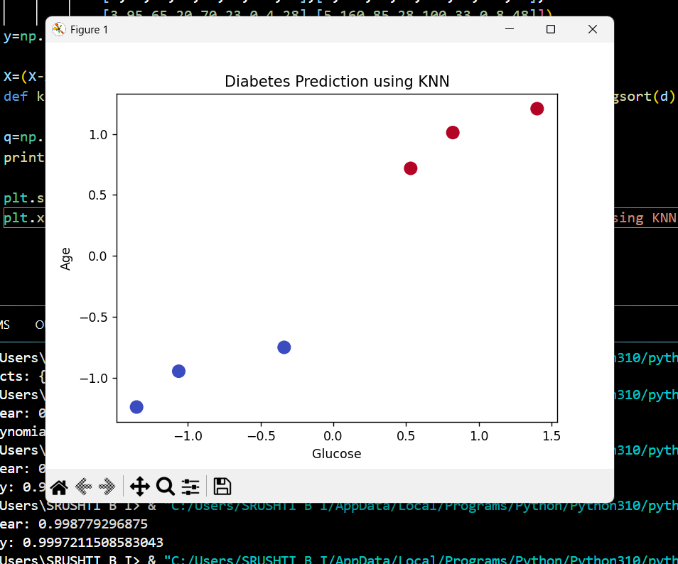

- K-means Clustering mode
import pandas as pd, matplotlib.pyplot as plt
from sklearn.cluster import KMeans
from sklearn.preprocessing import StandardScaler

df=pd.DataFrame({'Age':[22,25,47,52,46,56,55,60,28,30],
'Experience':[1,3,20,25,18,30,28,35,5,7],
'Income':[15000,20000,85000,100000,80000,120000,110000,150000,30000,35000]})

print("Employee Dataset:\n", df)
data_scaled = StandardScaler().fit_transform(df)
df['Cluster'] = KMeans(n_clusters=3, random_state=42).fit_predict(data_scaled)

plt.scatter(df['Experience'],df['Income'],c=df['Cluster'],cmap='viridis')
plt.xlabel('Experience'); plt.ylabel('Income'); plt.title('Employee Income Clusters');
plt.show()

OUTPUT:
Employee Dataset:
Age Experience Income
0 22 1 15000
1 25 3 20000
2 47 20 85000
3 52 25 100000
4 46 18 80000
5 56 30 120000
6 55 28 110000
7 60 35 150000
8 28 5 30000
9 30 7 35000
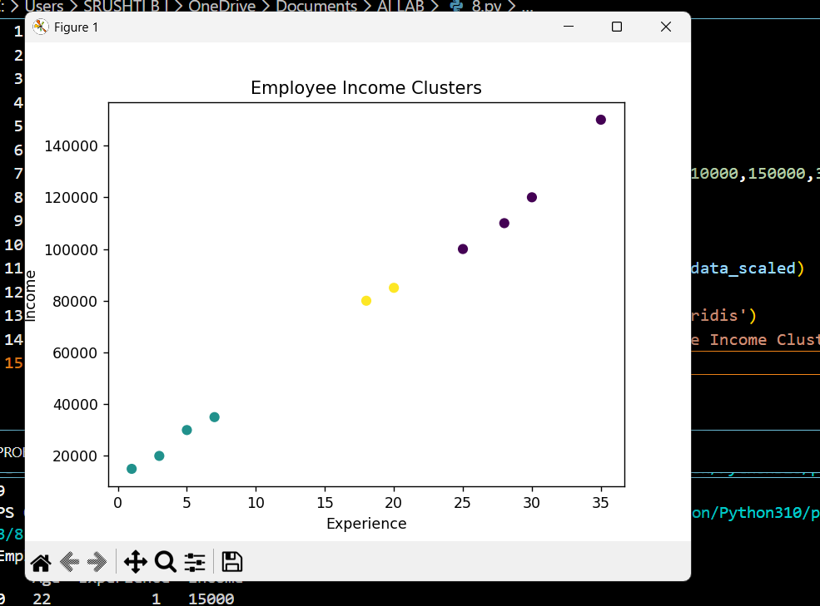

9. IRIS Flower
import numpy as np
from sklearn.datasets import load_iris
from sklearn.preprocessing import StandardScaler
from sklearn.decomposition import PCA
from sklearn.linear_model import LogisticRegression
from sklearn.model_selection import train_test_split
from sklearn.metrics import accuracy_score

X,y=load_iris(return_X_y=True)
sc=StandardScaler(); X=sc.fit_transform(X)
pca=PCA(1); X=pca.fit_transform(X)
Xtr,Xte,ytr,yte=train_test_split(X,y,test_size=0.2,random_state=42)
model=LogisticRegression().fit(Xtr,ytr)
print("Accuracy:",accuracy_score(yte,model.predict(Xte)))
new=np.array([[5.1,3.5,1.4,0.2]]); new=pca.transform(sc.transform(new))
print("Predicted Species:", load_iris().target_names[model.predict(new)][0])
OUTPUT:
Accuracy: 0.9
Predicted Species: setosa

10. Q- learning
import numpy as np, random

n_states, n_actions, goal = 5, 2, 4
Q = np.zeros((n_states, n_actions))
alpha, gamma, epsilon, episodes = 0.1, 0.9, 0.2, 500

for _ in range(episodes):
s = 0
while s != goal:
a = random.randint(0,1) if random.random() < epsilon else np.argmax(Q[s])
ns = s+1 if a==1 else max(0, s-1)
r = 10 if ns==goal else -1
Q[s,a] += alpha * (r + gamma * np.max(Q[ns]) - Q[s,a])
s = ns
print("Learned Q-table:")
print(np.round(Q, 2))

OUTPUT:
Learned Q-table:
[[ 3.09 4.58]
[ 3.11 6.2 ]
[ 4.57 8. ]
[ 6.19 10. ]
[ 0. 0. ]]

